Week 13 Quiz Instructions

Import the four sheets in the four workbooks Week 13 Quiz labeled workbooks (Clubs, Events, Memberships, and Students) to create an Access database which you should name Club Database for Week 13 Quiz followed by your name. Please enforce Referential Integrity when appropriate and remove any fields that do not have any data from your database. Establish the appropriate joins with the appropriate primary and foreign keys in the four tables. You will determine the primary and foreign keys by reviewing the two queries you are asked to develop.

The first query will provide the first and last names and email addresses for the members of each club as shown below. Save this query in Access as the Club Members query. Notice that this query has been sorted by club name. Here is what the Club Member Query should look like:

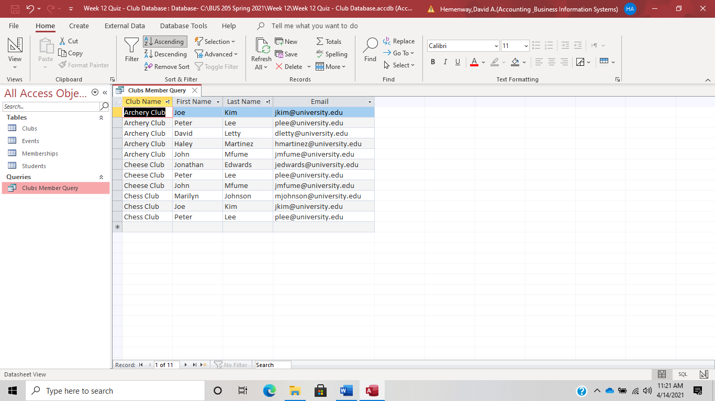

Now create a second query that should be saved as Club Events in Access. The fields should include the club’s name and list the events it has held. Note that the clubs have been put in alphabetical order. Here is what the Club Events query should look like:

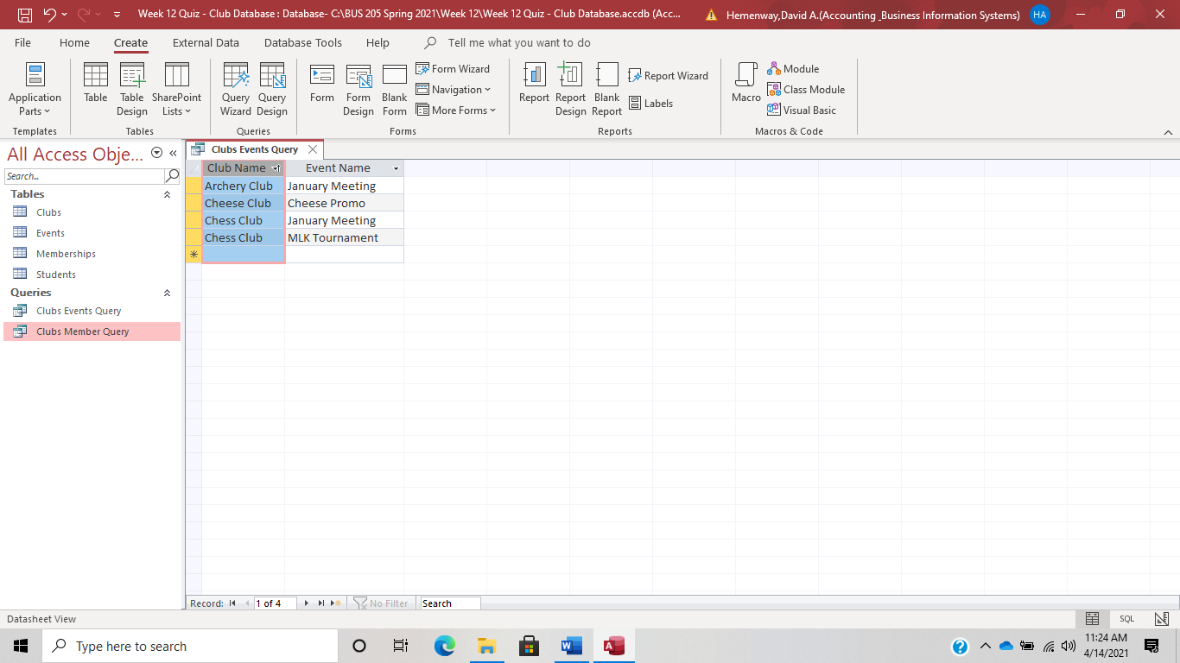

Make sure you save your Access database with the queries before you close Access and upload your database to Blackboard.